democracy decoded

Project Overview and Objective
This project involves cleaning, transforming, and analysing raw data using Excel and creating an interactive Power BI dashboard to derive meaningful business insights.
The main objective is to demonstrate data pre-processing techniques using Excel and an interactive Power BI dashboard visualization to make informed decisions.
data sources
Source Description and Timeline: India Data Portal: https://indiadataportal.com/ Search and 2009-2021.
Domain: Politics (Election).

problem statement

Understanding Election Outcomes:
Identifing the key factors that influenced victory or defeat across different states and constituencies.
Analyzing Voter Participation:
Measuring voter turnout percentages to determine public engagement levels in various election cycles.
Evaluating Candidate Diversity:
Analyzing the performance of candidates based on their category (General, SC,ST) and gender to understand representation.
Assessing Victory Margins:
Identifying “close-contest” seats versus “safe” seats by calculating the average winning margin percentage.
Tracking Historical Trends:
Monitoring how voting patterns and total votes obtained have changed over time using historical election dates.

attribute (column/features) details:
Attributes | Data Type | Description
Election Date | Date | The Specific date when the election was held.
State Name | Text | Name of the Indian State where the constituency is located.
Assembly No | Whole Number | The official constituency number assigned by the Election commission.
Assembly Constituency Name | Text | The Specific name of the legislative assembly seat (e.g., Thousand Lights).
Candidate Name | Text | Name of the individual contestant in the election.
Candidate Type | Text | Categorization of candidates based on reservation (General, SC,ST).
Sex | Text | Gender of the candidate (Male,Female,Others).
Party | Text | Political Party affiliation of the candidate.
Position | Whole Number | Final rank of the candidate based on votes(1 = winner).
Total Votes Obtained | Decimal Number | Total number of valid votes secured by the candidate.
Margin Percentage | Percentage | The difference in vote share between the candidate and the runner-up.
Turn out Percentage | Percentage | The percentage of total electors who actually cast their votes.

tools & technologies
● Excel: Data cleaning, transformation, and Pivot Tables.
● Power BI: Data modelling, DAX calculations, visualization, and interactive dashboard creation.
data pre-processing (excel/power query)
Tasks Performed:
● Data Cleaning & Transformation: Removed duplicates, handled missing values, standardized formats, and created calculated fields.
● Filtering & Sorting: Organized data to focus on relevant records.
● Pivot Tables: Generated Pivot Tables for data summarisation and initial insights.
● Convert the data into Fact and Dimension Table
data modelling and dax (power bi)
● Data Model: Connected Dimension tables to a central Fact table via One-to-Many (1:*) links.
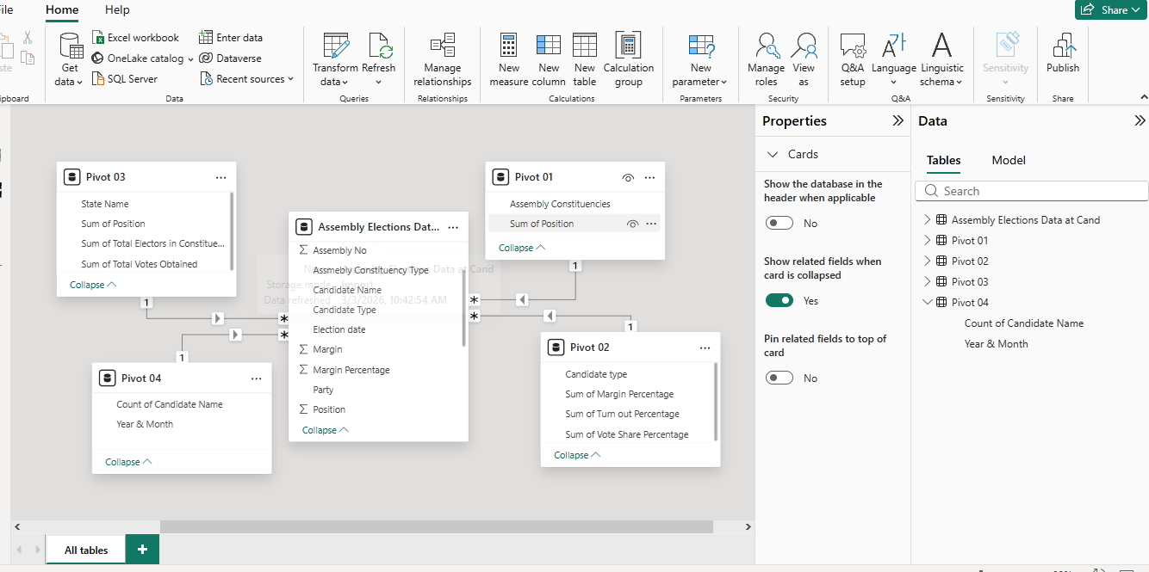
● Calculated Columns & DAX Measures: Key DAX Functions Used such as Sum,Average,Calculate & Count.
SUM: Used to calculate Total Votes (e.g., 7M votes).
AVERAGE:.Used tp find the Average Margin % (e.g., 4.28%)
Calculated Columns & DAX Measures:
Year & Month: Add custom column to coordinate year & month columns to create new column named “Election Date”.
DAX Measures:
Total Votes: SUM(‘Assembly Elections Data’[Sum of Total Votes Obtained])
Avg Margin %: AVERAGE (‘Assembly Elections Data’ [Margin Percentage])

analysis and visualizations (power bi)
1.Core KPI Cards:
Instruction:Use the Card Visual for single high-level metrics.
Insights: Highlights the overall health of the election data, such as 7M Total Votes and 4.28% Average Margin. It gives an immediate summary of the scale and competitiveness of the elections.
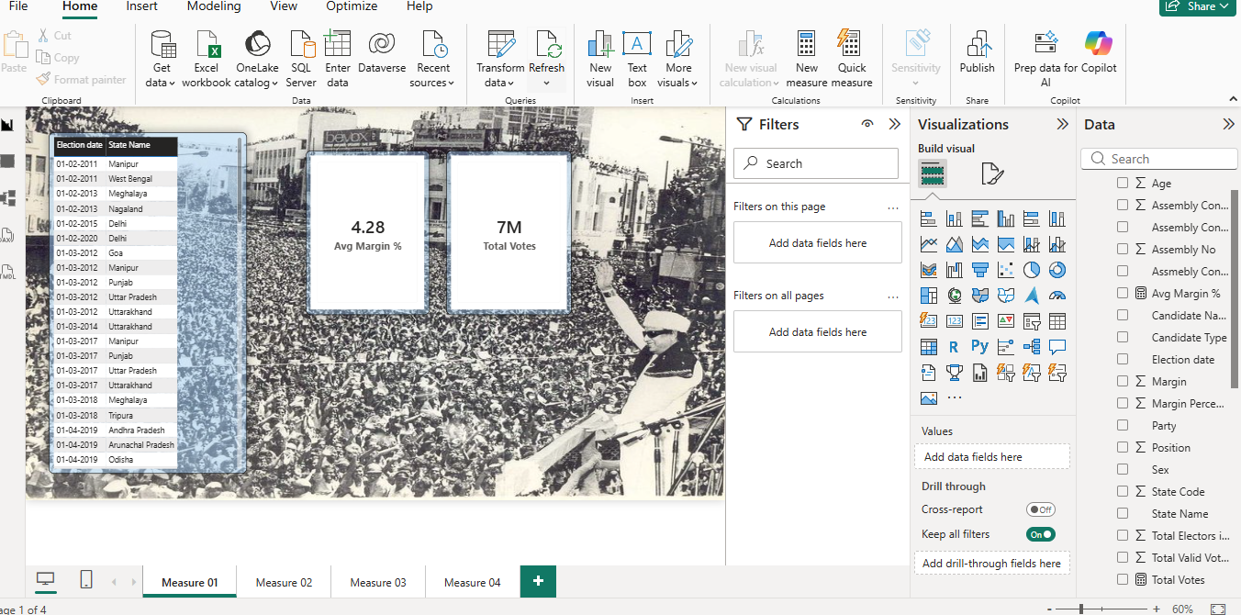
2.Gender & Category Bar Charts:
Instruction: Use clustered Bar chart to compare two different groups like ‘sex’ or ‘Candidate Type’.
Insight: This diagram helps identify which demographic (e.g., Male vs Female) has the highest Vote Share Percentage explains the “Why” behind a party’s performance in specific voter segments.
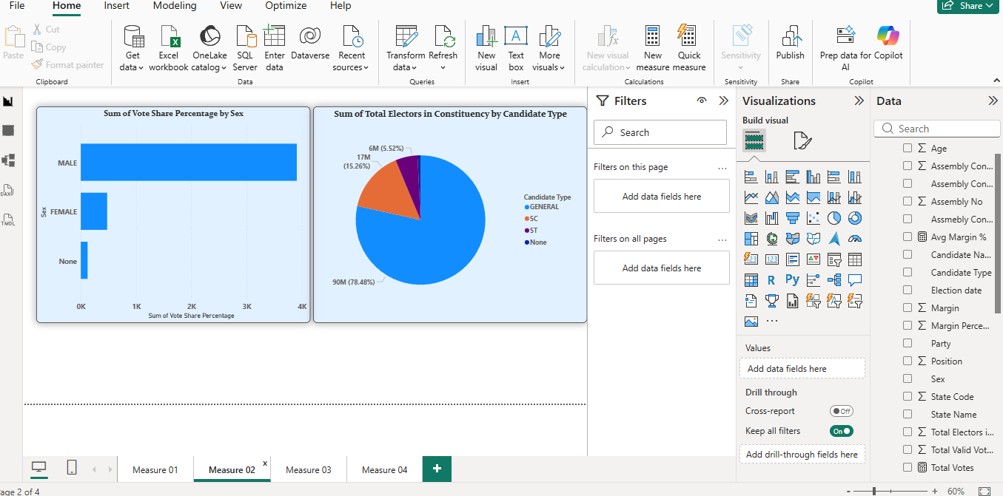
3.Constituency Distribution (Trend/Structural Insight):
Instruction: Use a Tree Map to visualize the volume of constituencies per state.
Insights: The size of the boxes indicates which states have more administrative seats (e.g., Uttar Pradesh vs Manipur). This helps in understanding the political weight of each state in the overall analysis.
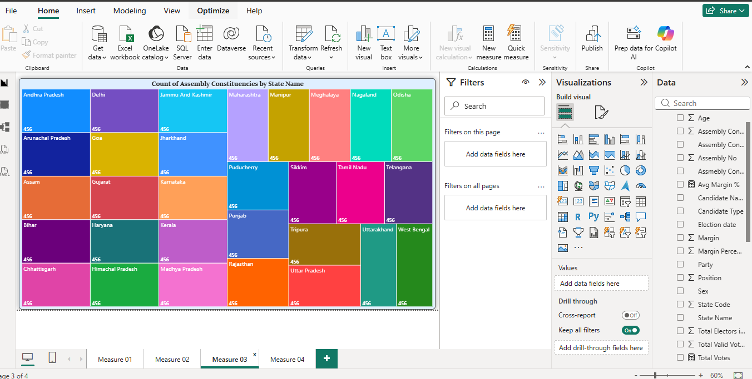
4. Detailed Elector Analysis (Performance Insight)
Instruction: Use a Stacked Bar Chart with the Zoom Slider enabled for large datasets.
Insight: Shows the total electors for every constituency. By using the zoom slider, users can focus on specific high-population areas without losing the context of the entire dataset.
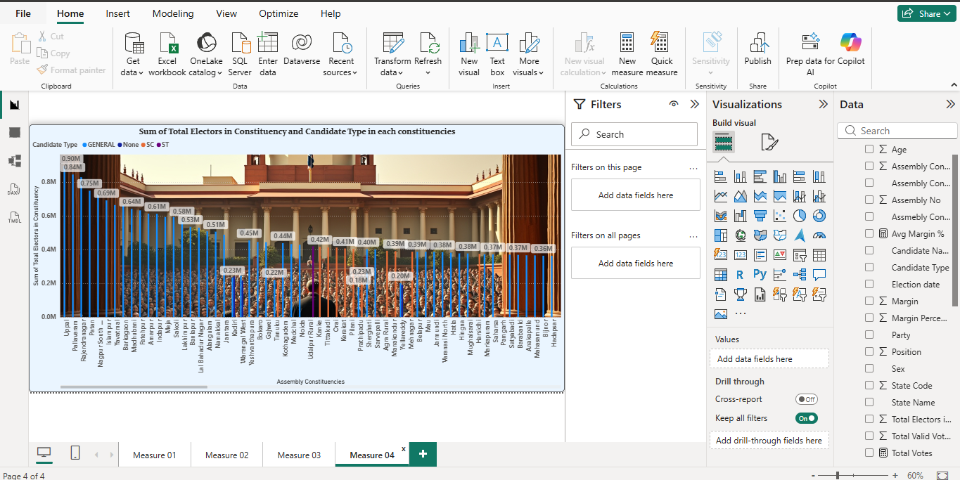

insight & conclusions
OVERVIEW

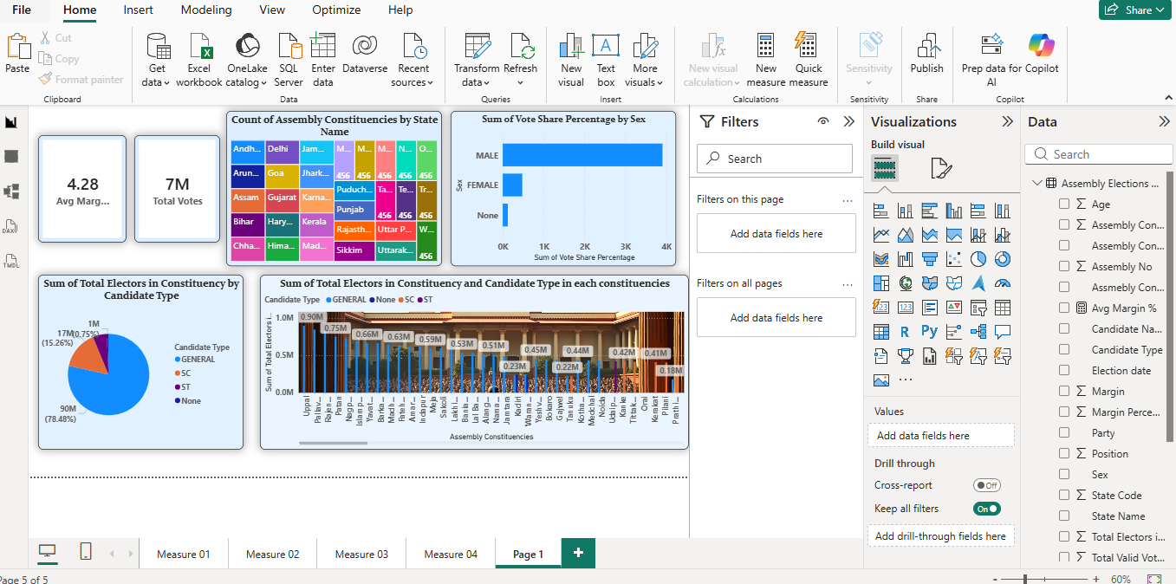
Key Findings: High scale, Tight Contests, Male Dominance, State weight, Voter variation.
Analysis Insights:
- Summarizes the actual results of the election.Shows key figures like Total Votes (7M) and Average Margin % (4.28%).
- Investigates why certain results happened by looking at categories. Compares data across Candidate Types (General,SC,ST) and Gender (Male/Female) to see which group influenced the win.
- Measures how strong the winners were in each constituency. Identifies “Safe Seats’ (high margin) versus “Close Contests” (low margin) using DAX Measures.
- Tracks how voting patterns changed over time. Uses the Election Date to show if voter turnout is increasing or decreasing across different years.

conclusions
The integration of Excel and Power BI proved effective for end-to-end data analysis, from raw data to visual reporting.

